Yr 9 Science
Physical Sciences
Test 1 - Waves

NAME: MARK:
1. Which of the following lists correctly arranges the different types of materials in order of
increasing speed of sound (i.e. from slowest to fastest)?

A Solids; liquids; gases
B Solids; gases; liquids
C Liquids; solids; gases
D Gases; liquids; solids
QUESTION | ANSWER
1
2
3
4
5
6
7
8
9
10
11

2. Some types of electromagnetic radiation are said to be more ‘energetic’ than others. Which of the following options best describes what determines how ‘energetic’ electromagnetic radiation is said to be?

A Higher frequency radiation is more ‘energetic’.
B Longer wavelength radiation is more ‘energetic’.
C Faster-moving radiation is more ‘energetic’.
D Radiation travelling in a vacuum is more ‘energetic’.

3. Which of the following statements best describes the motion of particles in a transverse wave?

A The particles vibrate parallel to the direction of energy transfer.
B The particles vibrate at right angles to the direction of energy transfer.
C The particles gradually spread out parallel to the direction of energy transfer.
D The particles gradually spread out at right angles to the direction of energy transfer.

4. Which of the following options best describes a sound wave with a wavelength of 40 cm?

A Compressions are 40 cm apart.
B Compressions are 20 cm apart.
C Compressions and rarefactions are 40 cm apart.
D Compressions and rarefactions are 10 cm apart.


5.

6. Which of the following options best describes the property of a sound that is determined by its amplitude?

A Speed
B Pitch
C Loudness
D Frequency

7. Which of the following options has the same meaning as a ‘compression wave’?

A A vibration wave.
B An elastic wave.
C A longitudinal wave.
D A transverse wave.

8.
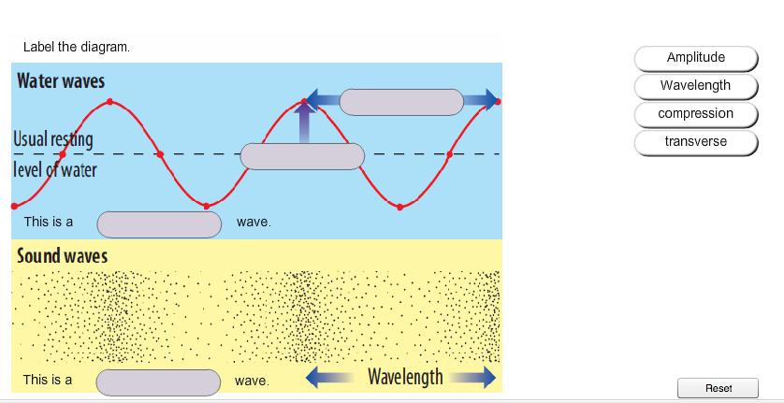

9. Which of the following options best describes the property of a sound that is determined by its frequency?

A Speed
B Pitch
C Loudness
D Amplitude

10. A man has a black patch over his right eye. He looks into a plane mirror. Which of the following diagrams best describes the image he sees?

 | A | 
 | B | 
 | C | 
 | D | 

11. Which of the following explanations best describes the relation between a ‘ray’ and a ‘beam’?

A Rays travel in straight lines; beams are formed when rays are deflected.
B A beam is what is seen when rays are scattered.
C A beam shows the path of light; a ray is a bundle of beams.
D A ray shows the path of light; a beam is a bundle of rays.

